# SAVEETHA SCHOOL OF ENGINEERING

**CAPSTONE PROJECT**

IMPLEMENTATION OF WAN(WIDE AREA NETWORK) USING CISCO PACKET TRACER

**NAME:** K.Lahari

**REGISTER NUMBER:** 192325118 **COURSE CODE:** CSA0747

**COURSE NAME:** Computer Network for IOT

## INTRODUCTION:

## On the vast landscape of networking, Wide Area Networks (WAN) play a pivotal role in enabling communication between geographically dispersed locations WAN facilitate the exchange of data and resources across different sites, connecting client and server systems over long distances. By integrating various technologies, WAN ensure seamless communication between offices, data centers, and remote users, supporting business operations and enabling real-time collaborations across different platforms, networks, and devices.

### Objectives:

* Design a WAN architecture.
* Establish connectivity between branches.
* Optimize network performance.
* Showcase network functionality.

## LITERATURE REVIEW:

## Wide Area Networks (WAN) enable communication across distant locations but are vulnerable to attacks like Distributed Denial of Service (DDoS). IP spoofing, and data breaches. Research highlights encryption, firewalls, and intrusion detection systems (IDS) as key security measures. DDoS is a major concern, with solutions focusing on traffic monitoring and packet filtering. Despite various approaches, no single solution can cover all security threats, making a layered defense necessary for robust WAN protection.

# METHODOLOGY:

**Software:**

* Cisco Packet Tracer

### Network Design:

Network consist of

* + 1 router
  + 3 switches
  + 9 PC’s

Each switch is connected with 3 pcs and switches are connected with router.

### IP Address Allocation

### Step 1:

### Decide on an IP range(e.g., 192.168.0.100/24).

### **Step 2:**

### Set up WAN interface(for internet).

### Configure IP and enable DHCP.

### **Step 3:**

### Connect all 3 switches to the router’s LAN ports.

### Assign management IP’s to switches if necessary.

### **Step 4:**

### Distribute 3 PCs to each switch.

### Set PCs to use DHCP or assign static IP’s in the 192.168.0.x range.

### **Step 5:**

### Ping between PCs and check WAN (internet) access.

### **Step 6:**

### Configure basic firewall rules and secure switch ports.

### **Protocols:**

### Multiprotocol Label Switching (MPLS).

### Border Gateway Protocol (BGP).

### Internet Protocol Security (IPsec).

### Dynamic Host Configuration Protocol (DHCP).

### Open Shortest Path First (OSPF).

### Simple Network Management Protocol (SNMP).

**RESULT:**

### Network Design:

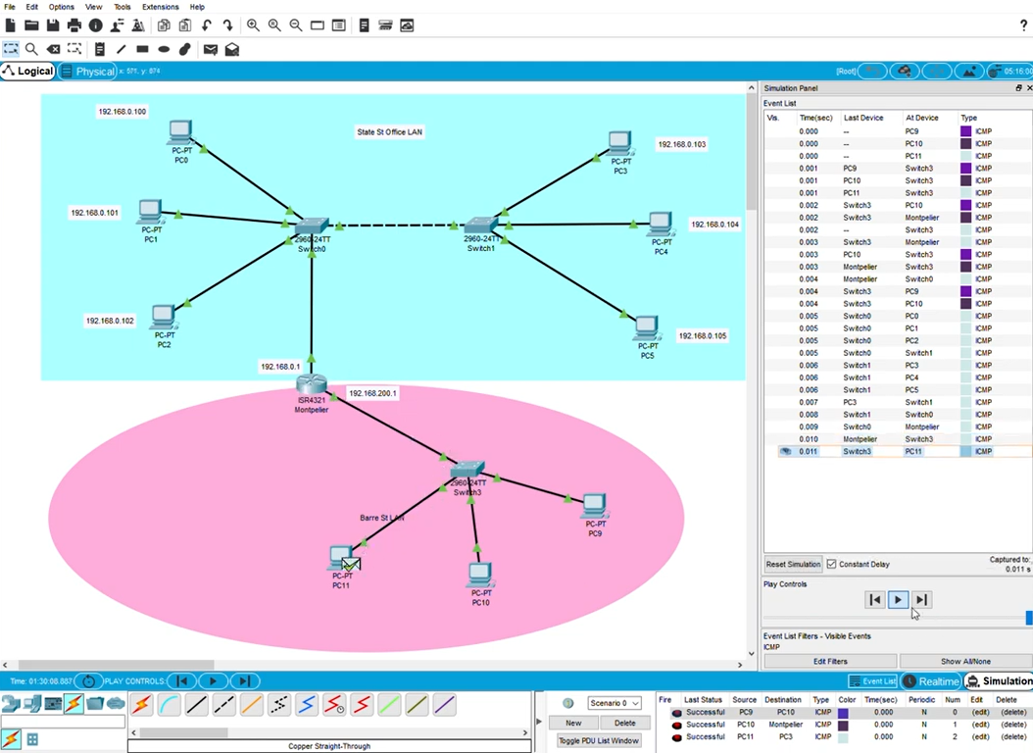

## CONCLUSION:

The successful deployment of a Wide Area Network (WAN) demonstrates the ability to connect multiple locations across large geographic areas while ensuring reliable and efficient data communication. WAN technology plays a crucial role in linking remote offices, data centers, and cloud environments, enabling seamless information exchange and collaboration.

By implementing protocols like MPLS, BGP and etc., the network achieves high performance, scalability and security. The network’s architecture supports traffic prioritization through QoS, enhancing the delivery of criticcal applications such as voice, video, and data services.

In summary WAN network provides a robust and scalable solution for organizations,meeting the growing demands of global connectivity, with the flexibility to accommodate future expansions and technological developments.